PC 1141 PHYSICS I
(Semester I: AY 2021-2022)

Time Allowed: 2 Hours

INSTRUCTIONS TO CANDIDATES

- This Examination paper contains five short questions.
- Answer ALL questions.
- All answers are to be written on the answer books.
- This is a CLOSED BOOK examination.
- The total mark is 100.
- Some useful information is given on Page 2 of this question paper.

Useful Information:

$$Gravitational Constant, G=6.673 ×{10}^{11} N∙m^{2}/kg^{2}$$

$$Acceleration due to gravity, g=9.80 m/s^{2}$$

$$I_{cm}\left(for a cylinder\right)=\frac{1}{2}MR^{2}$$

$$I_{CM}\left(for a solid sphere\right)=\frac{2}{5}MR^{2}$$

$$I_{CM}\left(for a spherical shell\right)=\frac{2}{3}MR^{2}$$

Question 1

An egg of mass 0.050 kg is in a stiff box of mass 0.300 kg, surrounded on all sides by padding that constraints the egg in place. A force of $F=\left(4.61\hat{i}+2.80\hat{j}\right)N$ acts on the outside of the box, in addition to the force of gravity (which is oriented in the -y direction).

- Draw the force body diagram for the egg-box system and for the egg.
- What is the acceleration of the egg-box system and the net force on the egg?
[8]

Question 2

A uniform brick of length L is laid on a smooth horizontal surface. Other equal bricks are now piled on as shown, so that the sides from the continuous plane, but the ends are offset at each block from the previous brick by a distance of 0.15L. How many bricks can be stacked in t his manner before the pile topples over?

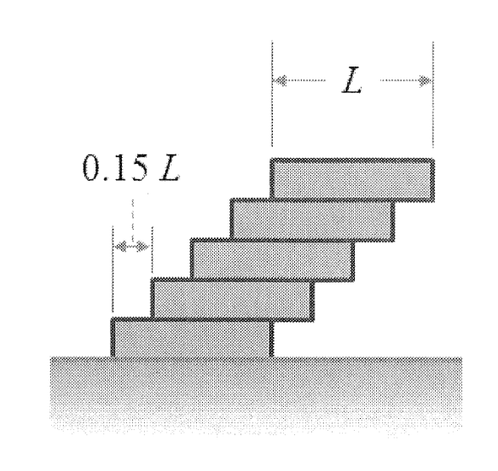

[8]
Question 3

The left-hand end of a long, taut string is moved harmonically up and down with amplitude 0.050m. This motion produces a wave of wavelength $λ=1.50m$ that travels in the $+x$ direction at speed $υ=173 m/s$

- What is the frequency, f, of the traveling wave?
- What are the maximum transverse velocity and maximum transverse acceleration of a point along the string?
[8]

